Problem 1:
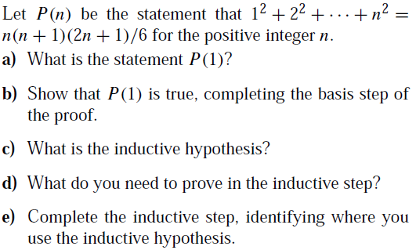
Problem 2:
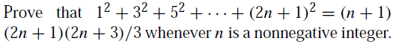
Problem 3:
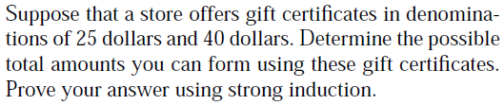
Problem 4:
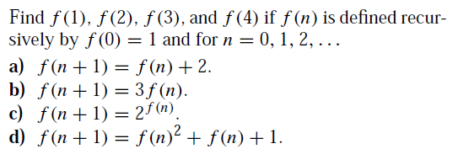
Problem 5:
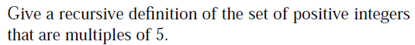
Problem 6:
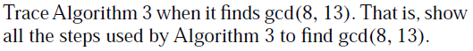
Problem 7:
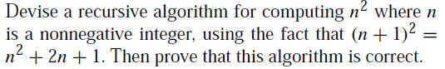
Problem 8:
